Contents
Abstract 2
1. Introduction / Background 2
1.1 Objectives of the Study 3
2. Methodology 3
2.1 Dataset 3
2.3 Exploratory Data Analysis (EDA) 4
2.3 Data Preprocessing 6
2.4 Machine Learning Models 7
2.5 Evaluation Metrics 7
3. Results 7
3.1 Baseline Results 7
3.2 Final Model Selection 8
4. Conclusion 9
5. Contributors 10

Abstract
Anaemia affects more than one billion people globally. It is caused by low haemoglobin levels resulting from iron or vitamin deficiencies, blood loss or genetic conditions like sickle cell anaemia and thalassemia. Anaemia diagnosis is challenging due to costly blood tests, lack of medical personnel and limited infrastructure especially in rural areas. Machine learning models can analyse the records of complete blood count for early anaemia detection and therefore eliminate the need for expert healthcare professionals. This study explores the use of machine learning techniques for the early detection and classification of anaemia using routine blood test data. The dataset consists of haematological features such as haemoglobin level, red blood cell count, and related indices, with multiple anaemia types and a healthy class. Several machine learning models were developed and compared, including Logistic Regression, Support Vector Machine, Decision Tree, Random Forest, and Gradient Boosting. Model performance was evaluated using accuracy, precision, recall, F1-score, and ROC–AUC metrics. The results show that tree-based models achieved the highest classification accuracy, with Decision Tree reaching approximately 98% accuracy and Random Forest achieving around 96%, while the tuned Support Vector Machine model also demonstrated robust performance with approximately 91% accuracy and good generalization. These findings highlight the potential of machine learning models as effective tools for early anaemia detection and clinical decision support.

1. Introduction / Background
Anaemia is a common blood disorder that affects millions of people worldwide. It occurs when the body does not have enough healthy red blood cells or haemoglobin to carry oxygen effectively. Early detection of anaemia is important because untreated cases can lead to fatigue, organ damage, complications in pregnancy, and reduced quality of life. In some cases, anaemia may also be a sign of serious underlying conditions such as nutritional deficiencies, chronic diseases, or blood cancers.
Traditionally, anaemia is diagnosed through laboratory blood tests and manual interpretation by medical professionals. While these methods are reliable, they can be time-consuming and may not always provide fast support for early screening, especially in resource-limited settings. With the increasing availability of medical data, machine learning offers an opportunity to assist healthcare professionals by automatically identifying patterns in blood test results that are linked to different types of anaemia.
Machine learning models can analyse multiple blood parameters at the same time and learn complex relationships that may not be obvious through manual analysis. This can help in detecting anaemia earlier, classifying its type more accurately, and supporting clinical decision-making. Early and accurate detection is especially important because different types of anaemia require different treatments.
In this study, machine learning techniques are applied to a dataset containing haematological parameters such as haemoglobin levels, red blood cell count, and red blood cell indices. These features are commonly used in routine blood tests and provide important information about the size, shape, and haemoglobin content of red blood cells. The dataset includes samples from healthy individuals as well as patients with different types of anaemia, allowing the models to learn patterns associated with each condition.
The performance of different machine learning algorithms is evaluated to determine their effectiveness in identifying various anaemia types. The goal is to explore how data-driven methods can support faster and more reliable anaemia screening in clinical practice.

1.1 Objectives of the Study
This study aims to develop and evaluate machine learning models for the early detection and classification of anaemia using routine blood test data. The main objective is to determine how accurately algorithms such as Logistic Regression, Support Vector Machines, Random Forest, Decision Tree, and Gradient boosting can identify distinct types of anaemia as well as distinguish them from healthy cases. By analysing key blood parameters, the study seeks to understand the ability of these models to support faster and more reliable screening. The goal is to explore whether machine learning can serve as a helpful decision-support tool for healthcare professionals in diagnosing anaemia at an early stage.

2. Methodology

2.1 Dataset
This study uses a structured haematological dataset containing routine blood test parameters collected for anaemia analysis. The dataset includes features such as haemoglobin (HGB), red blood cell count (RBC), mean corpuscular volume (MCV), mean corpuscular haemoglobin (MCH), and mean corpuscular haemoglobin concentration (MCHC). Each record is labelled according to anaemia type or as non-anaemic. The dataset contains multiple anaemia classes, with some imbalance between common and rare conditions.

2.3 Exploratory Data Analysis (EDA)
Exploratory Data Analysis was conducted to better understand the structure and characteristics of the anaemia dataset before model development. The initial analysis included examining the dataset size, feature types, and class labels. All input features consisted of numerical haematological parameters, making the dataset suitable for machine learning classification without the need for complex data transformation.
The class distribution analysis showed that the dataset contains multiple anaemia types along with a non-anaemic (healthy) class. However, the number of samples was not evenly distributed across classes, indicating the presence of class imbalance. Some anaemia types appeared more frequently than others, which justified the use of class weighting and robust evaluation metrics in later modelling stages.
Summary statistics and feature distribution plots were used to examine key blood parameters such as haemoglobin (HGB), red blood cell count (RBC), mean corpuscular volume (MCV), mean corpuscular haemoglobin (MCH), and mean corpuscular haemoglobin concentration (MCHC). These features showed noticeable variation across different anaemia categories, suggesting that they contain meaningful patterns for classification. The insights gained from EDA supported the choice of feature scaling, model selection, and evaluation strategies used in this study.

Table 1: ANOVA
Features with significant difference between anaemia types (ANOVA, p < 0.05) | P-Value
WBC | p = 2.8672e-35
LYMp | p = 4.4059e-07
NEUTp | p = 4.8108e-28
RBC | p = 3.1247e-04
HGB | p = 3.0650e-52
MCV | p = 1.2459e-18
MCHC | p = 5.6304e-44
PLT | p = 3.5857e-82
PDW | p = 1.1302e-04
PCT | p = 8.2595e-04

The ANOVA test was used to determine whether there are statistically significant differences in the means of each numerical blood parameter across the different anaemia types (as encoded in Diagnosis encoded).
Significant features (p < 0.05): These are blood parameters whose mean values differ significantly between at least some of the anaemia groups. This means these features are likely to be useful for distinguishing between anaemia types, as their distributions are not the same across all groups.
Non-significant features (p ≥ 0.05): These features do not show strong evidence of mean differences between groups, so they may be less informative for classification.
The features listed as significant by ANOVA are important candidates for further analysis and for building predictive models, as they capture differences between anaemia types.
These results support the use of these features in machine learning models for anaemia classification and may also provide clinical insight into which blood parameters are most relevant for distinguishing between different forms of anaemia.

Figure 1: Distribution of Key Blood Parameters
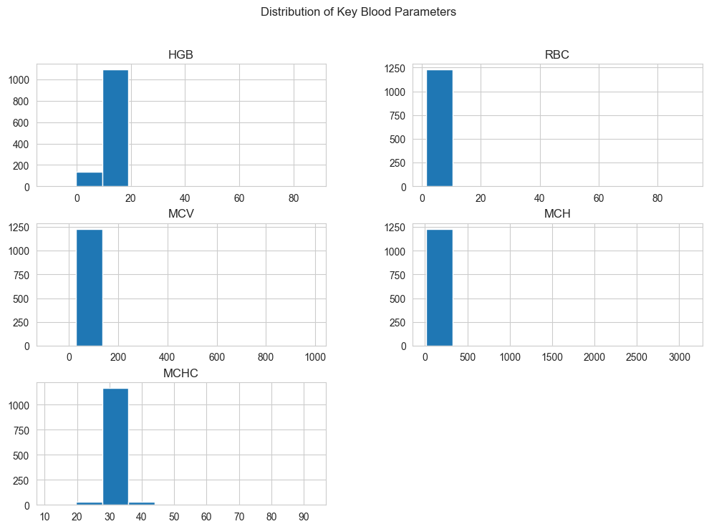
An examination of the distributions of key blood parameters indicates that the blood test values fall within clinically realistic ranges and exhibit sufficient variability to represent different types of anaemia. In particular, features related to red blood cell size and haemoglobin levels display greater dispersion, which enhances the models’ ability to distinguish between the various anaemia categories.

Figure 2: Distribution of Anaemia Types
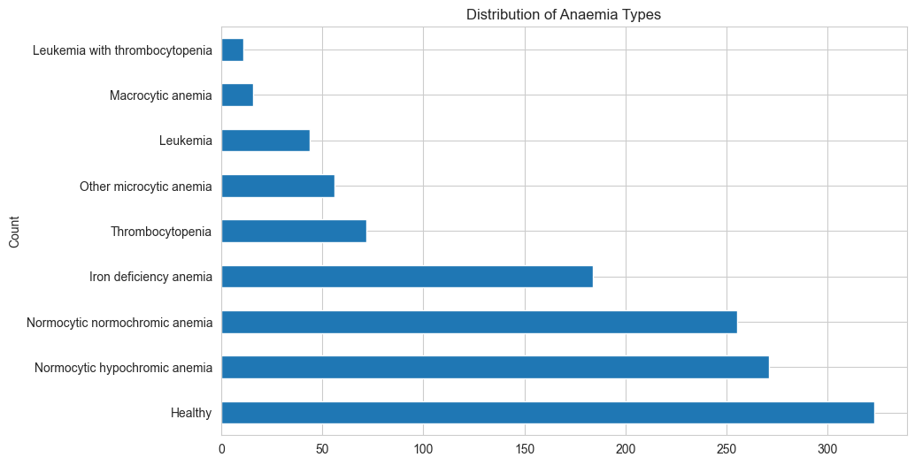
An evaluation of the distribution of anaemia types reveals a class imbalance, with certain anaemia categories being well represented while others have relatively few samples. This imbalance can make it more challenging for the model to learn and accurately predict rare conditions. To address this issue, class weighting and detailed per-class performance evaluation are applied to ensure that the model performs effectively across both common and less frequent anaemia types.

Figure 3: Feature Correlation Matrix
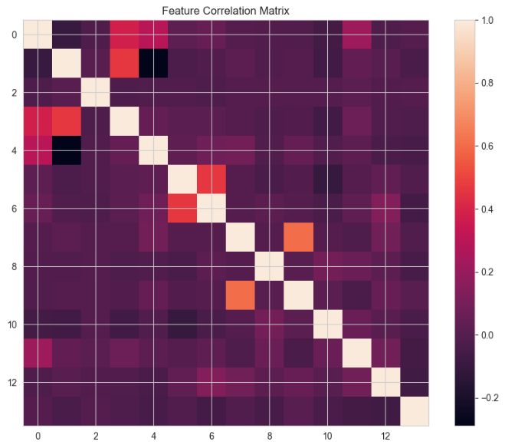
The correlation matrix indicates that most blood-related features exhibit low to moderate correlations with one another, suggesting that they capture distinct and complementary information rather than redundant signals. As a result, the models are able to learn from multiple informative features, with minimal risk of instability arising from highly correlated inputs.

2.3 Data Preprocessing
Before model training, the dataset was cleaned and pre-processed to ensure reliable and unbiased results. The dataset initially contained 1,281 records and 15 variables. During exploratory analysis, 49 duplicate records were identified and removed, as they accounted for less than 5% of the total data and could have negatively impacted model performance. The categorical class labels were then encoded into numerical values to ensure compatibility with machine learning algorithms. Subsequently, the data was split into training and testing sets to enable objective model evaluation. Finally, feature scaling was performed using standardization so that all numerical features contributed equally to the learning process, which is particularly important for distance-based models such as Support Vector Machines (SVM).

2.4 Machine Learning Models
Several supervised machine learning models were implemented and compared in this study to identify the most effective approach for early anaemia detection. The models evaluated include Logistic Regression, Support Vector Machine (SVM), Decision Tree, Random Forest, and Gradient Boosting. Each model represents a different learning strategy, allowing for a comprehensive comparison between linear, tree-based, and ensemble methods.
Logistic Regression was used as a baseline model due to its simplicity and interpretability in medical classification tasks. Support Vector Machine was selected for its ability to handle complex decision boundaries and perform well with scaled numerical data. Decision Tree models were included to capture non-linear relationships in the dataset, while Random Forest and Gradient Boosting were applied as ensemble methods to improve prediction accuracy by combining multiple decision trees. All models were trained and evaluated using the same pre-processed dataset to ensure a fair and consistent comparison.

2.5 Evaluation Metrics
The performance of all models was evaluated using standard classification metrics. These included accuracy, precision, recall, and F1-score to assess both overall and class-level performance. Confusion matrices were used to visualize correct and incorrect predictions across different anaemia types, providing insight into model strengths and weaknesses.
In addition, Receiver Operating Characteristic (ROC) curves and Area Under the Curve (AUC) values were used to evaluate each model’s ability to distinguish between classes based on predicted probabilities. These metrics were especially important due to the presence of class imbalance in the dataset, as they provide a more reliable assessment than accuracy alone.

3. Results

3.1 Baseline Results
The performance of five machine learning models, Logistic Regression, Support Vector Machine (SVM), Decision Tree, Random Forest, and Gradient Boosting, was evaluated using accuracy, precision, recall, F1-score, confusion matrices, and ROC–AUC curves. Initial results showed that Logistic Regression and SVM performed reasonably well, with SVM achieving approximately 91% accuracy after hyperparameter tuning. These models demonstrated good generalization and stable performance across anaemia classes but were outperformed by tree-based models.
Among the tree-based approaches, Decision Tree achieved the highest classification accuracy at approximately 98%, followed by Random Forest with around 96% accuracy. Gradient Boosting also showed strong performance, but slightly lower consistency compared to Random Forest. ROC–AUC analysis indicated that tree-based models provided strong class separation, especially for common anaemia types.
Figure 4: ROC–AUC analysis
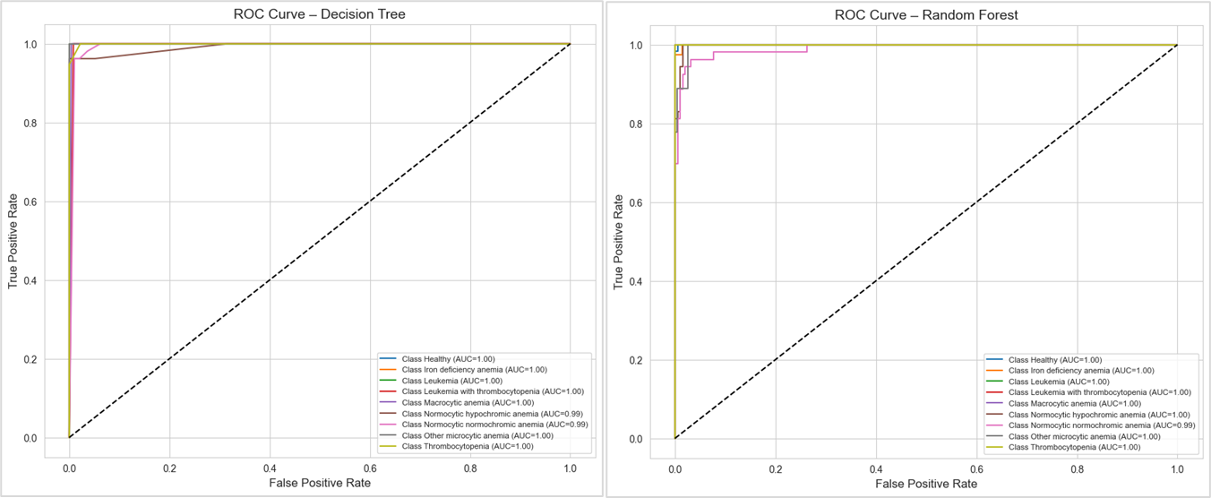

3.2 Final Model Selection
Although the Decision Tree model achieved the highest accuracy, Random Forest was selected as the final model for this study. This decision was based on its strong overall performance, high accuracy, and improved generalization ability compared to a single decision tree. Random Forest reduces overfitting by combining predictions from multiple trees, making it more stable and dependable when applied to unseen data.
Support Vector Machine was also a strong candidate due to its consistent performance and good ROC–AUC results; however, its accuracy was lower than that of the tree-based ensemble models. Considering both performance and reliability, Random Forest was chosen as the most suitable model for early anaemia detection. The results suggest that ensemble learning methods are particularly effective for analysing haematological data and can serve as reliable decision-support tools in clinical settings.

4. Conclusion
The results of this study show that machine learning models can effectively detect and classify different types of anaemia using routine blood test parameters. Both Logistic Regression and Support Vector Machine models achieved good performance, but their effectiveness improved significantly after hyperparameter tuning. The tuned Logistic Regression model showed strong overall accuracy and better balance across classes compared to its baseline version. However, the tuned SVM model achieved the highest performance, with over 90% accuracy and strong F1-scores for both common and rare anaemia types. This indicates that the patterns within the haematological data are well captured by machine learning techniques, especially models capable of forming clearer decision boundaries.

In addition to these, tree-based models, Decision Tree, Random Forest, and Gradient Boosting were also evaluated. These models performed competitively, with Random Forest and Gradient Boosting often matching or exceeding the accuracy of Logistic Regression and SVM, especially in handling class imbalance and capturing complex feature interactions. Their ROC curves showed strong separability for most anaemia types, with Random Forest and Gradient Boosting providing robust AUC values across all classes. Decision Tree, while simpler, still provided interpretable results and reasonable class separation, though its performance was slightly lower than ensemble methods.

A key advantage of these tree-based models is their inherent ability to handle non-linear relationships and feature interactions without extensive preprocessing or hyperparameter tuning. Unlike SVM and Logistic Regression, which benefit from careful tuning, Random Forest and Gradient Boosting often deliver strong baseline performance due to their ensemble nature and built-in regularization. This makes them especially suitable for medical datasets where feature relationships may be complex and unknown. Decision Trees, while more prone to overfitting, can still provide valuable insights and serve as a baseline for model interpretability.

The ROC results for these models confirm their reliability: ensemble methods like Random Forest and Gradient Boosting consistently achieve high AUC values, indicating strong discrimination between anaemia types. Their performance is robust even without tuning, making them practical choices for clinical applications where rapid deployment and interpretability are important.

Overall, the findings suggest that machine learning, particularly ensemble tree-based models and SVM, has strong potential to support early anaemia screening and assist healthcare professionals in making faster and more consistent diagnostic decisions. The use of class weighting and careful model selection ensures that minority conditions are detected with good sensitivity, and the consistency between cross-validation and test performance indicates good generalization ability.

5. Contributors
Table 2: Contributors
Name | Contribution
Jude Prince Onuh | Data sourcing, Data pre-processing, modelling, evaluation, and reporting
Nombulelo Sithole | Data pre-processing, modelling, evaluation, reporting and presentation (ppt)

